AWS Glue Crawler Lambda Trigger

1. Create S3 bucket
2. Create Glue Crawler

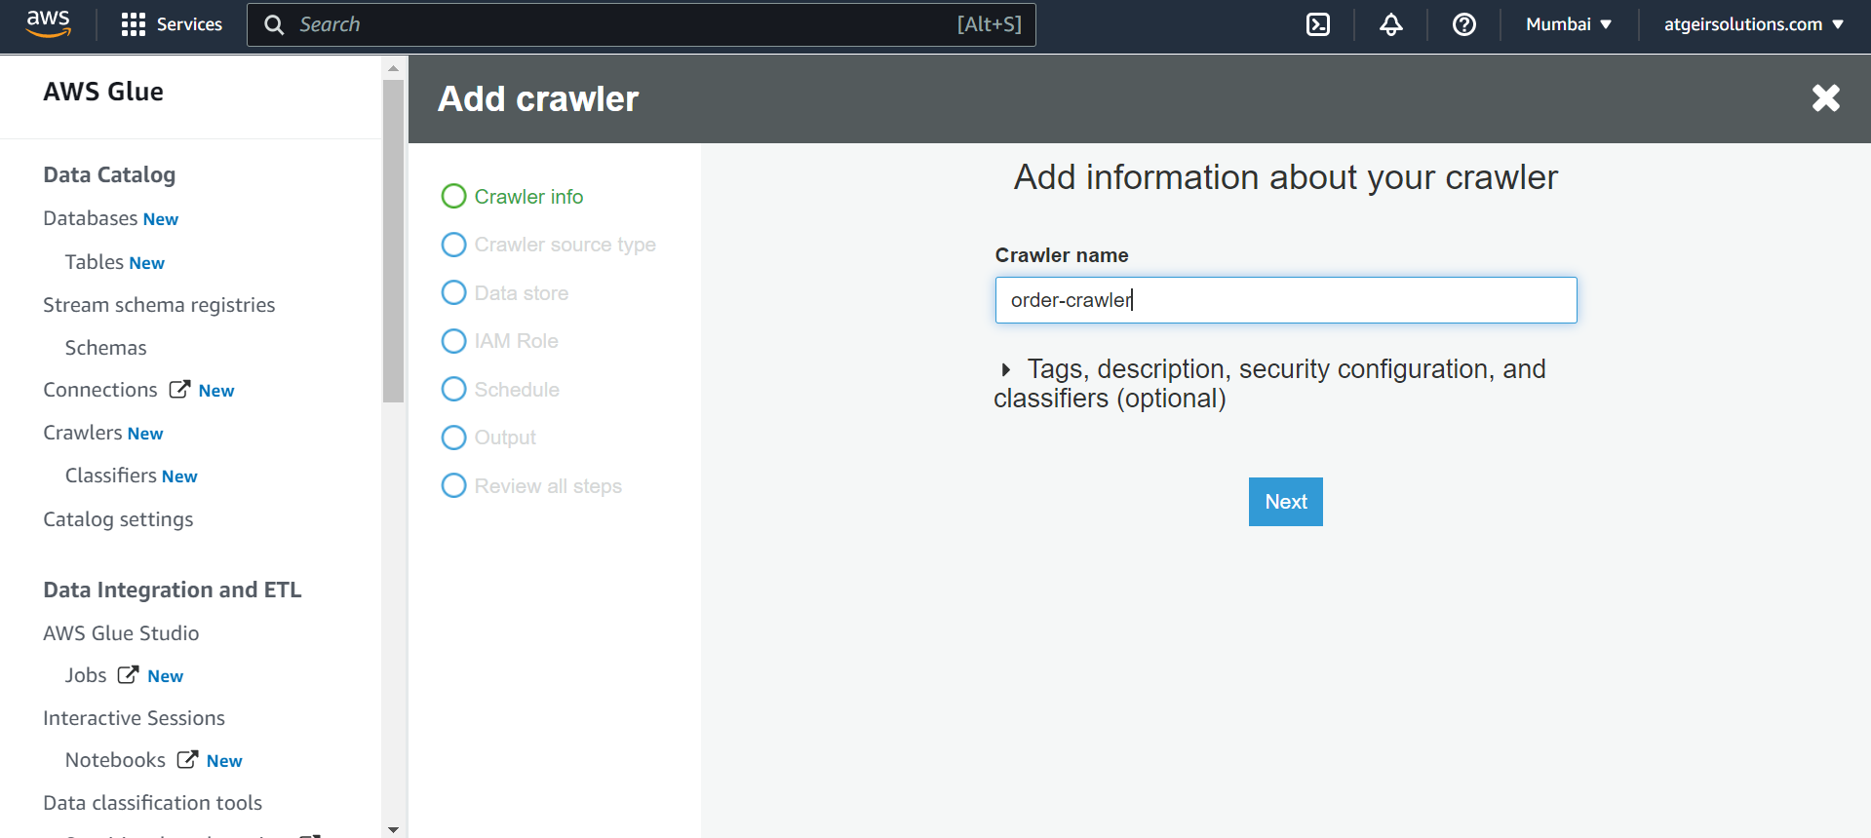

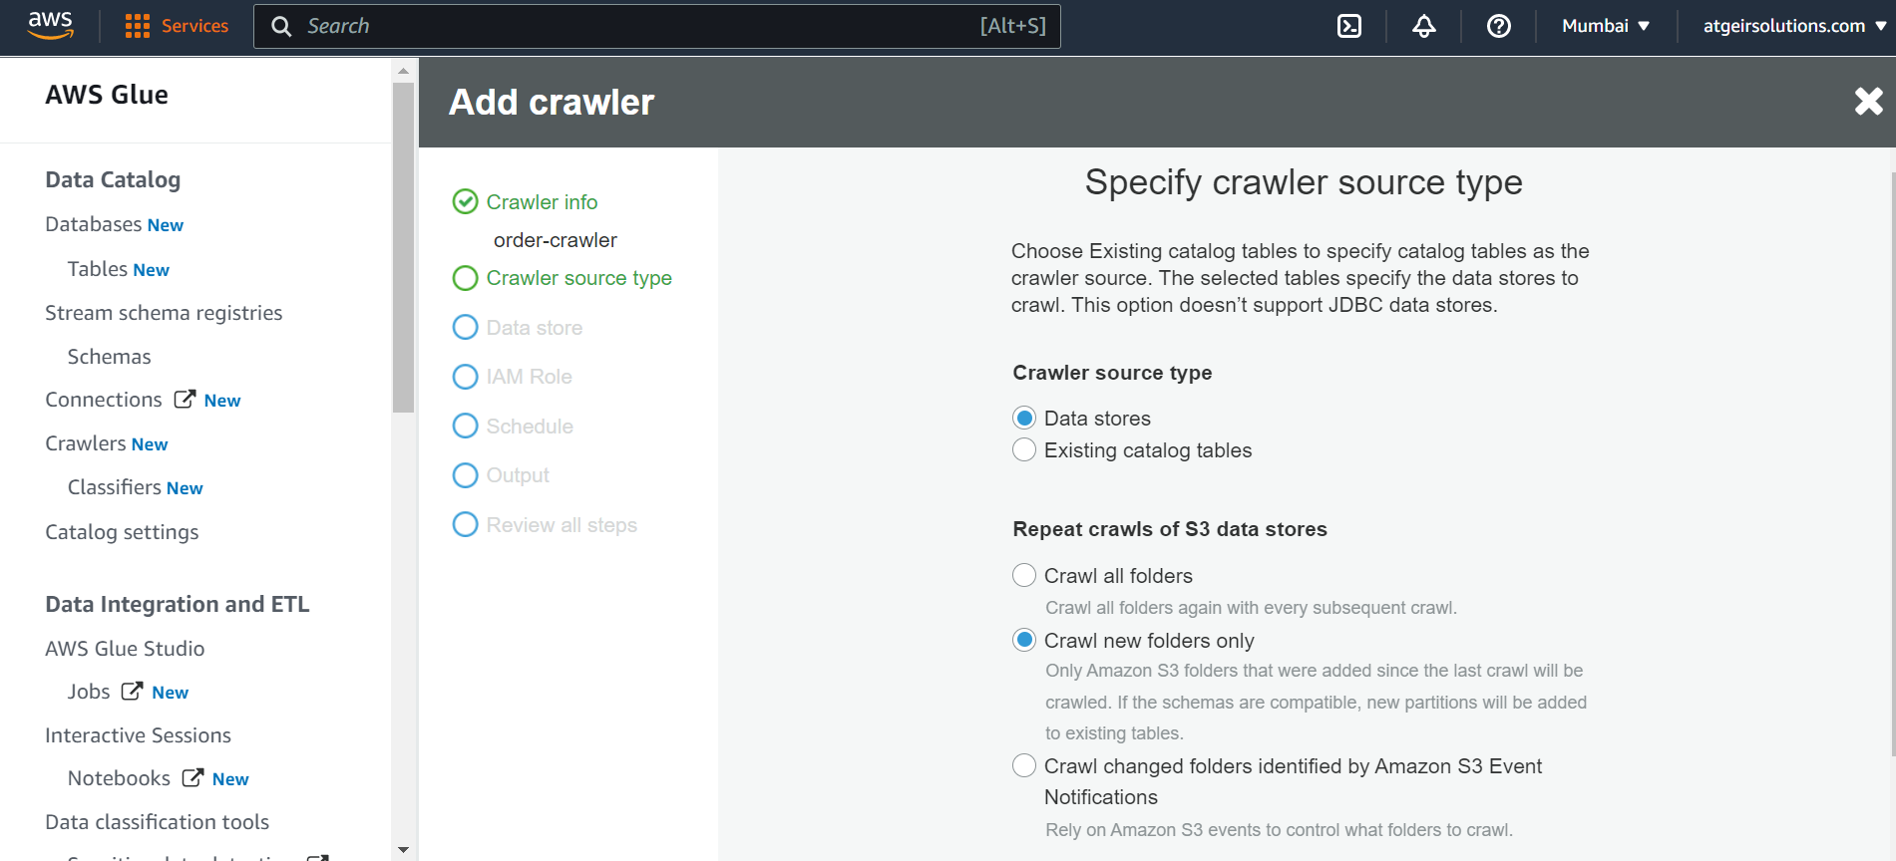

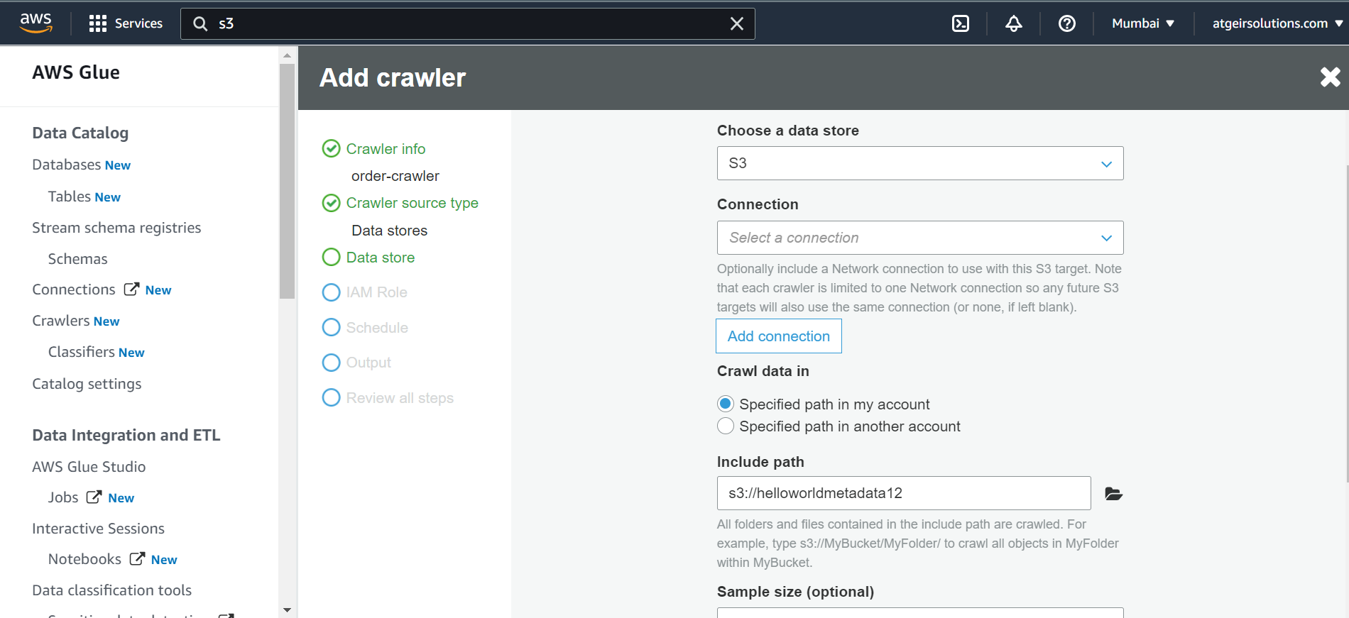

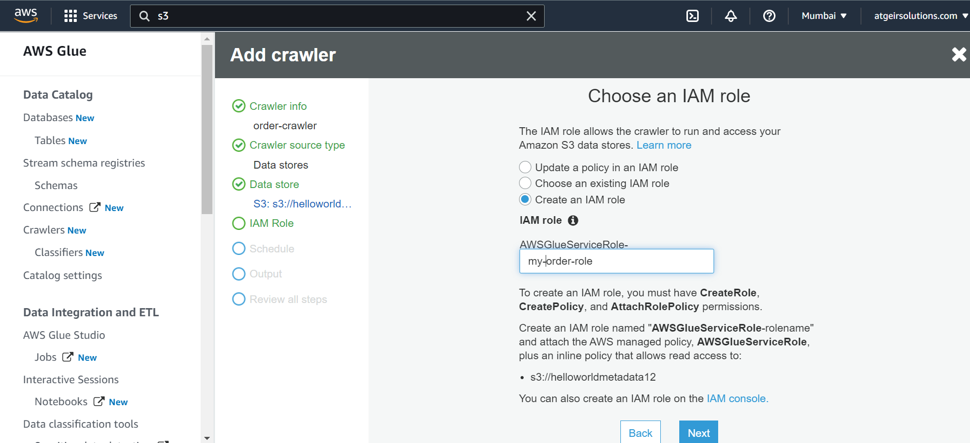

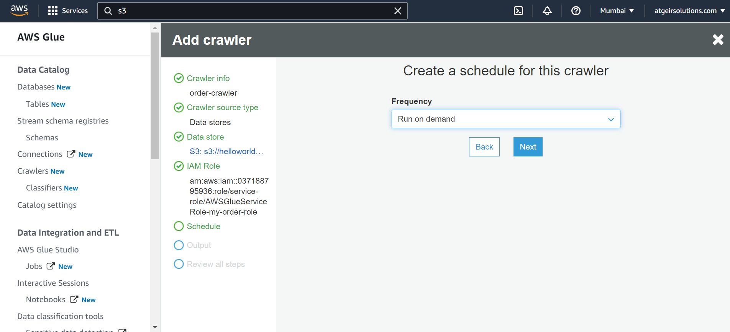

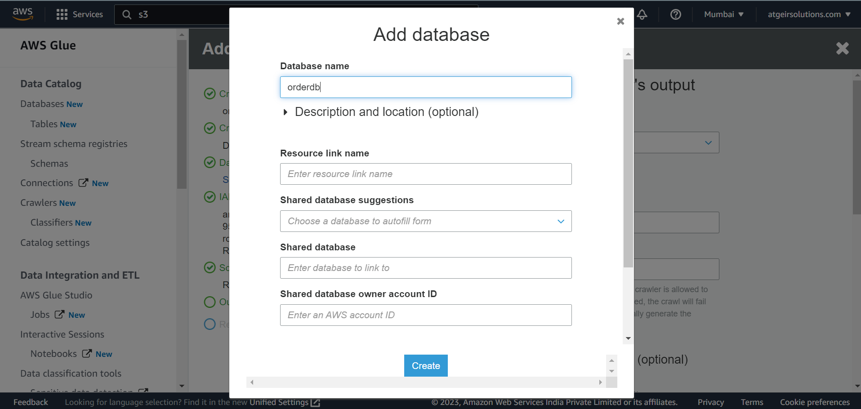

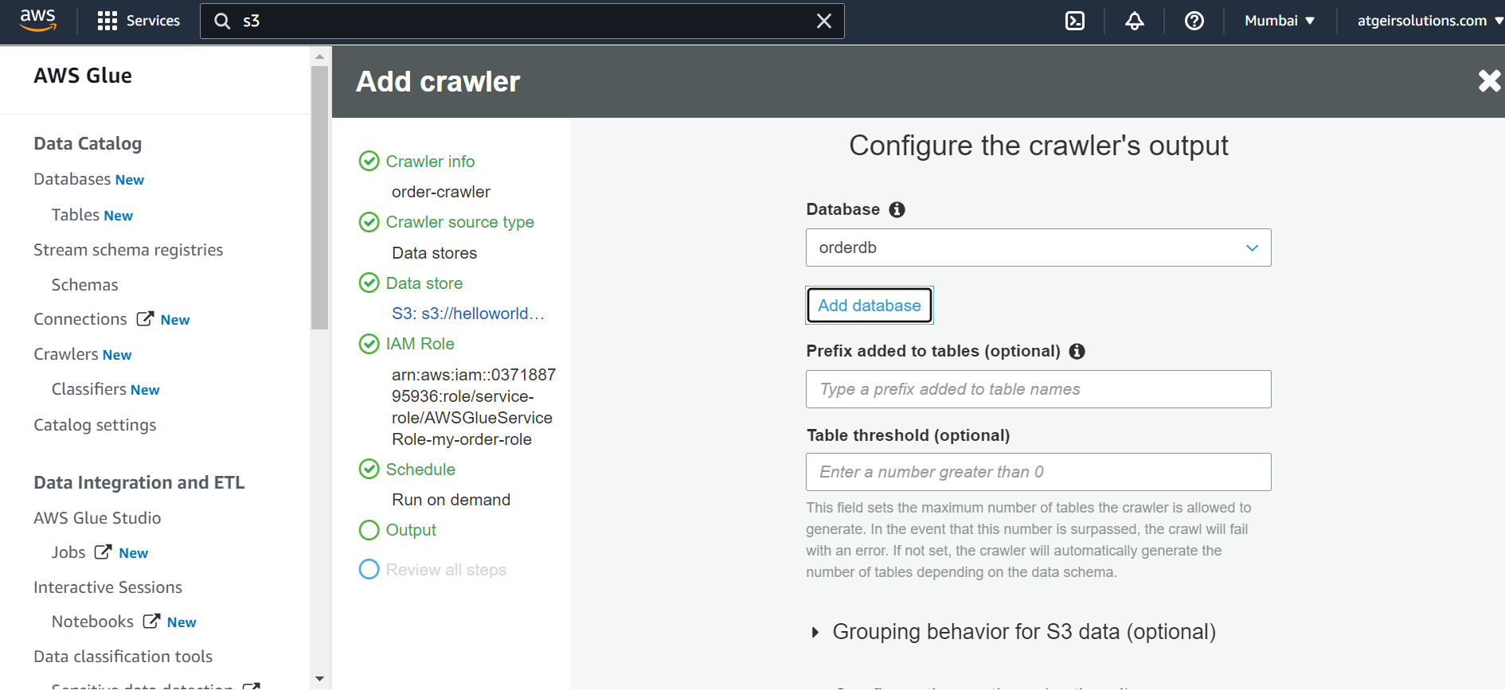

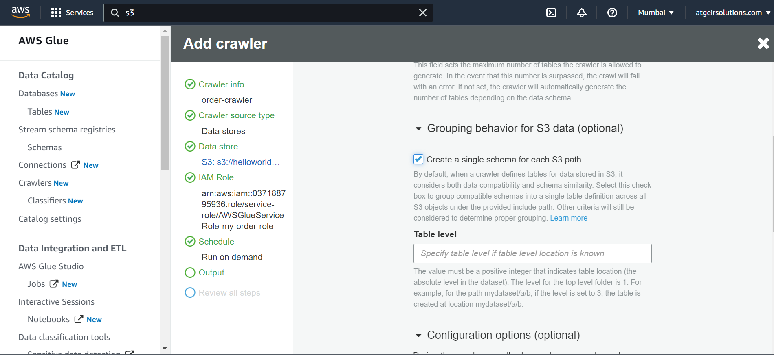

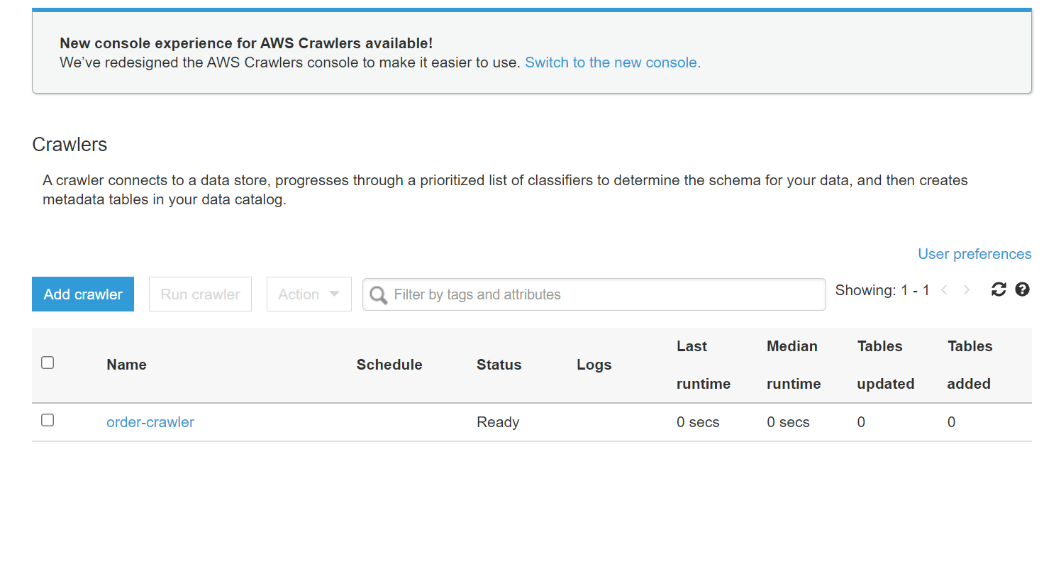

1. Create lambda function

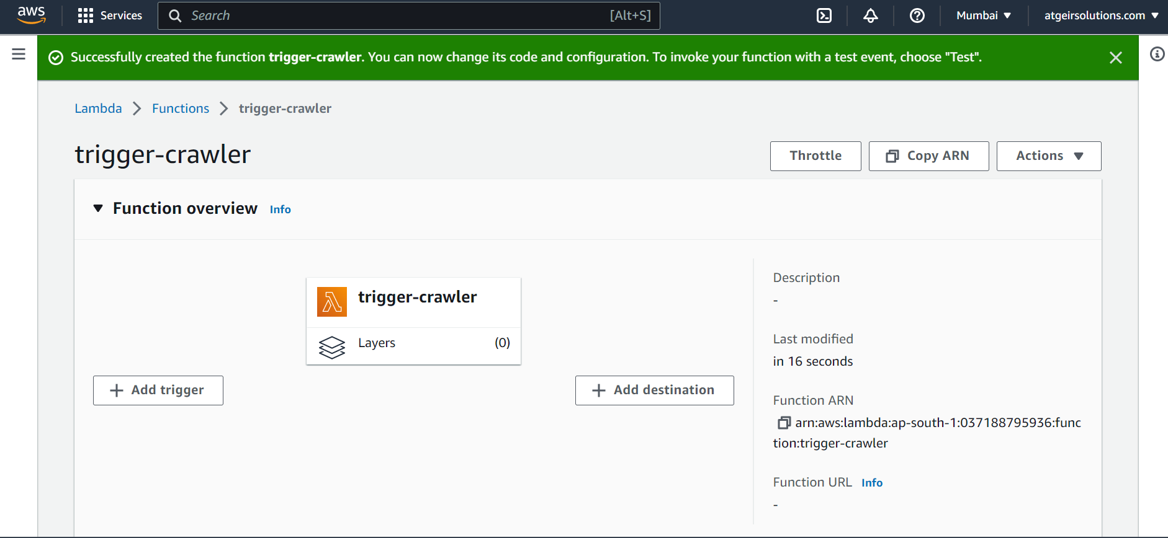

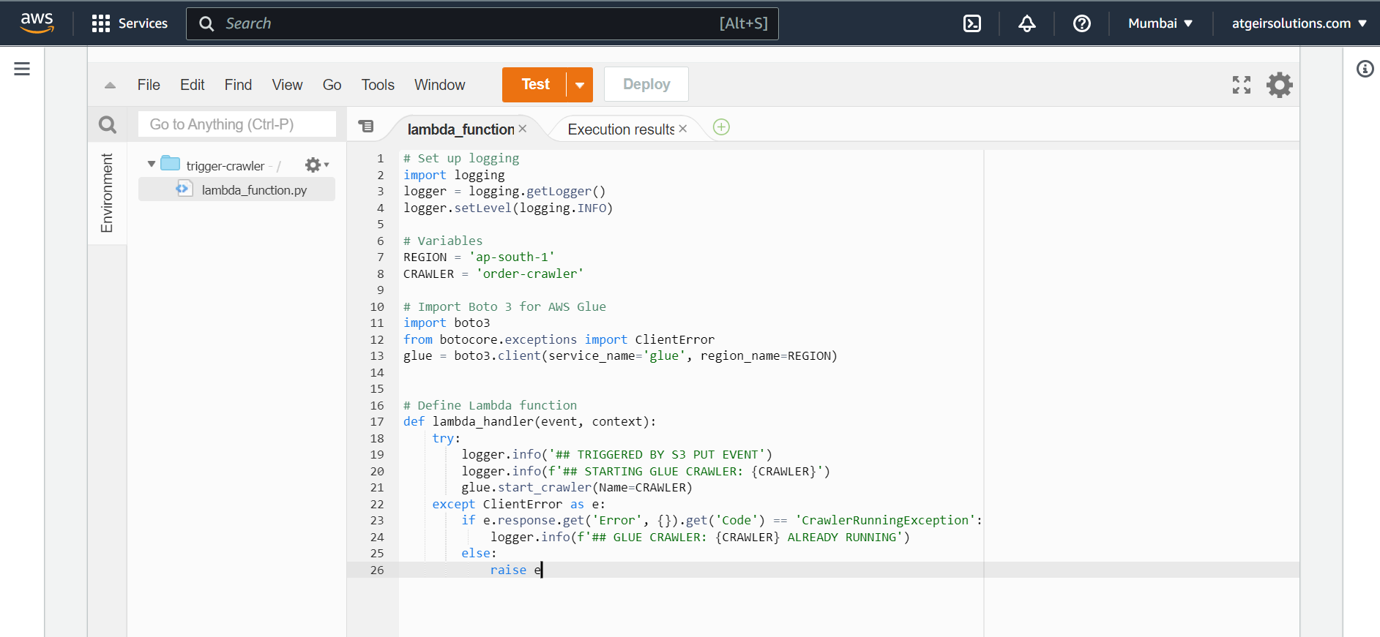

# Set up logging

import logging

logger = logging.getLogger()

logger.setLevel(logging.INFO)

# Variables

REGION = 'ap-south-1'

CRAWLER = 'order-crawler'

# Import Boto 3 for AWS Glue

import boto3

from botocore.exceptions import ClientError

glue = boto3.client(service_name='glue', region_name=REGION)

# Define Lambda function

def lambda_handler(event, context):

try:

logger.info('## TRIGGERED BY S3 PUT EVENT')

logger.info(f'## STARTING GLUE CRAWLER: {CRAWLER}')

glue.start_crawler(Name=CRAWLER)

except ClientError as e:

if e.response.get('Error', {}).get('Code') == 'CrawlerRunningException':

logger.info(f'## GLUE CRAWLER: {CRAWLER} ALREADY RUNNING')

else:

raise e

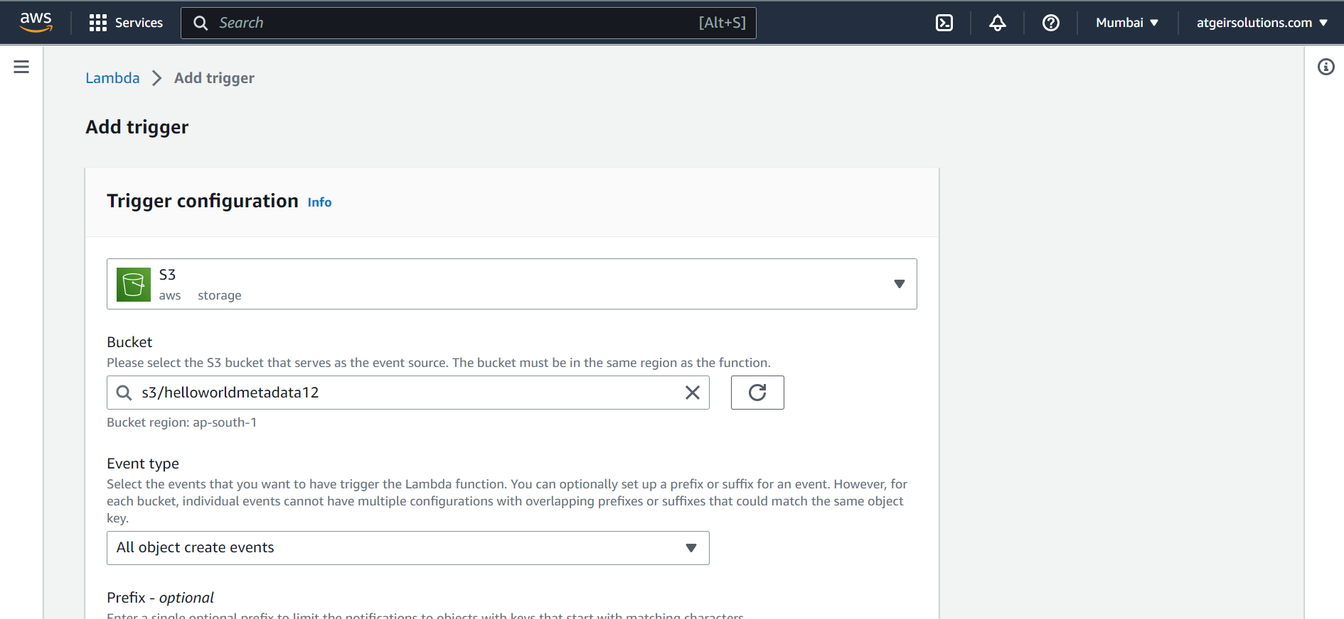

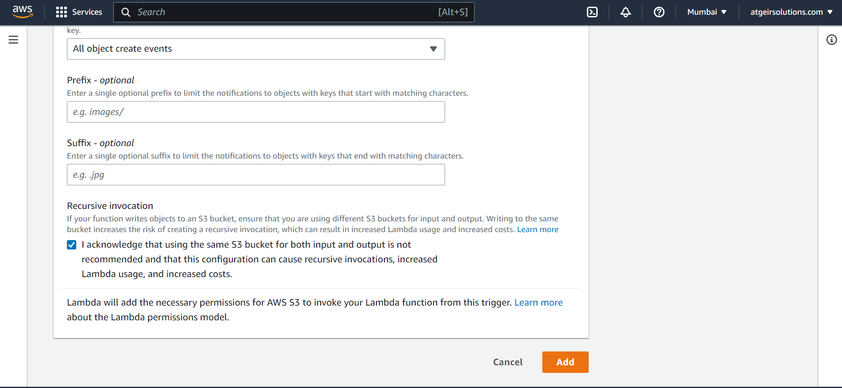

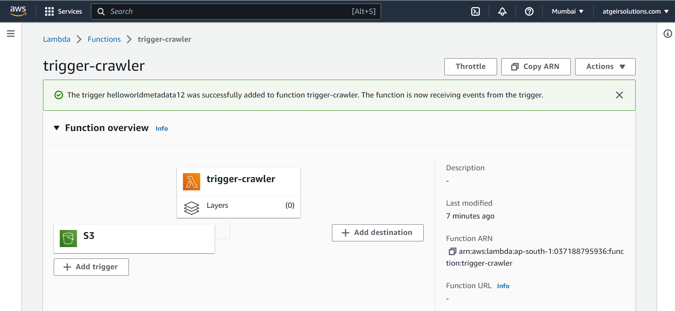

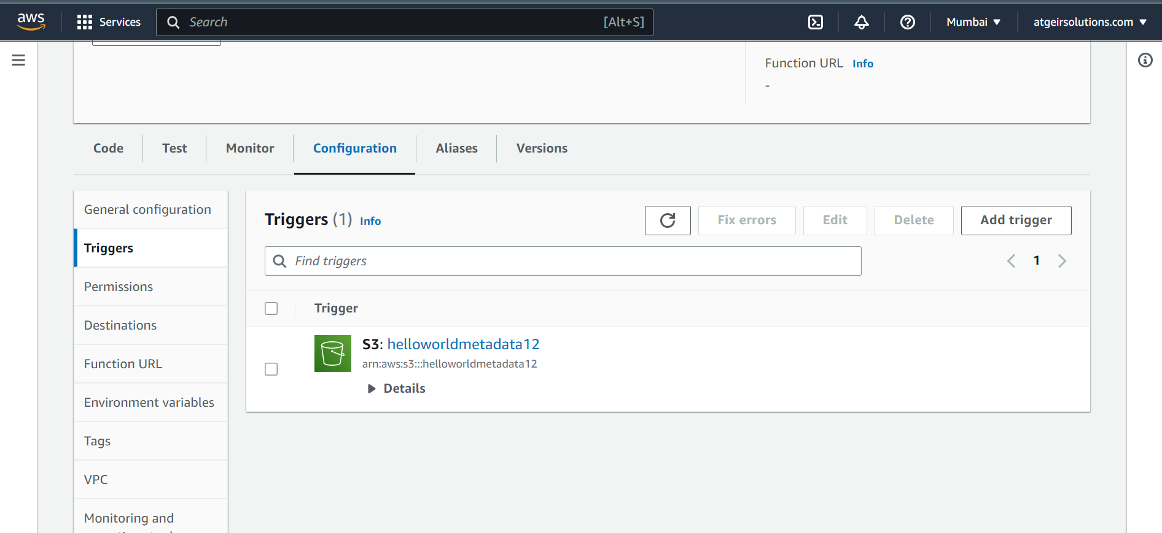

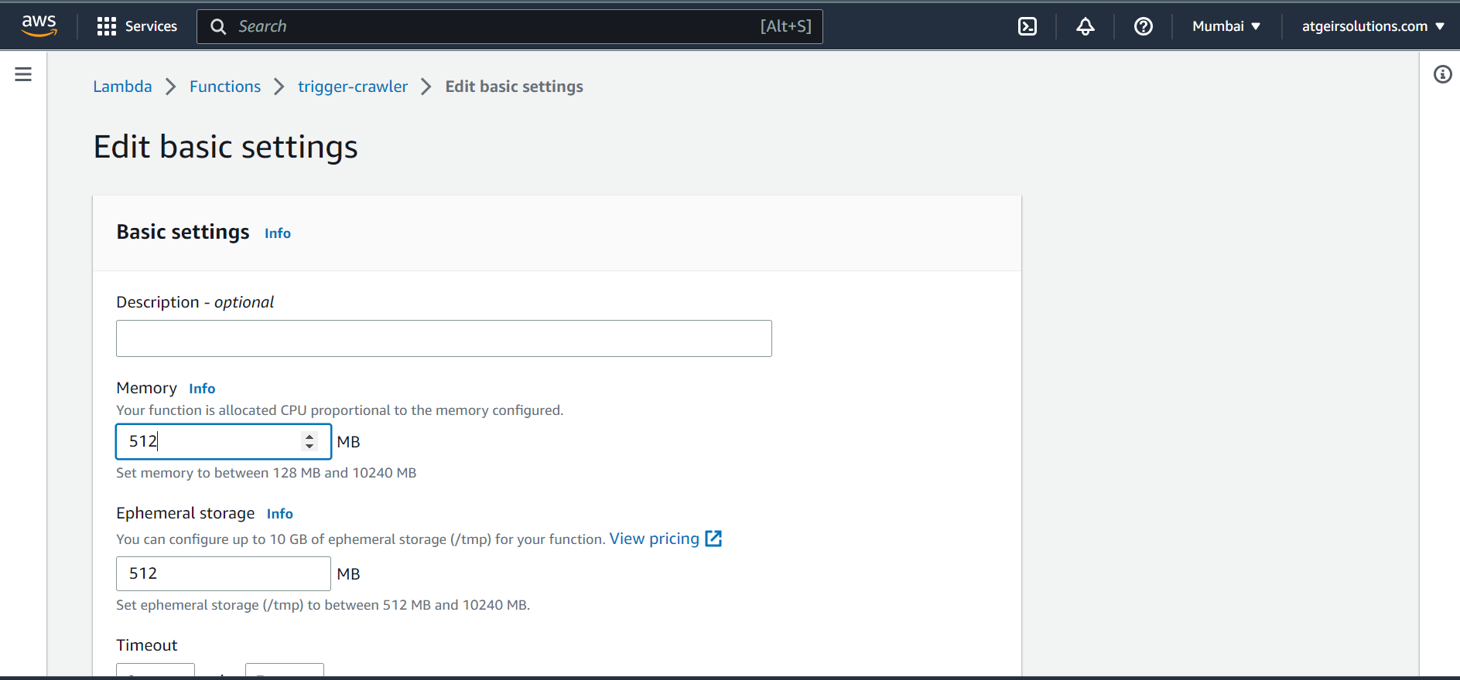

In permissions, select role name (link)

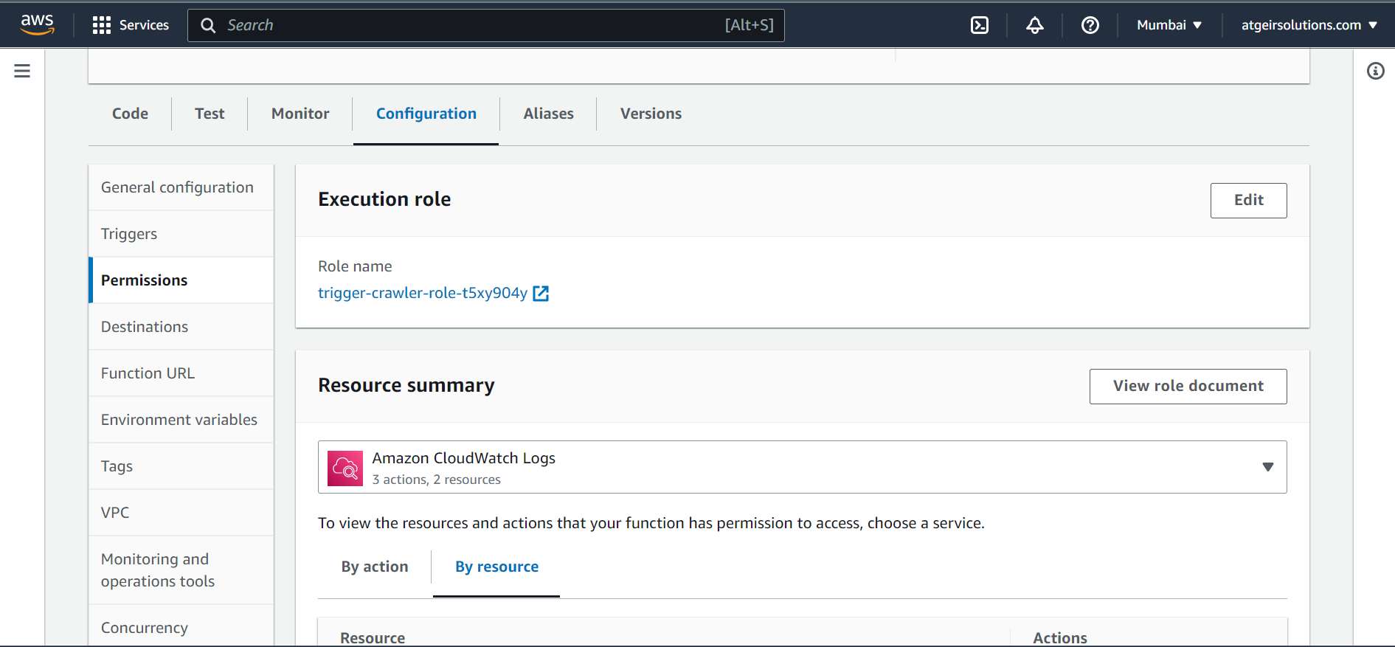

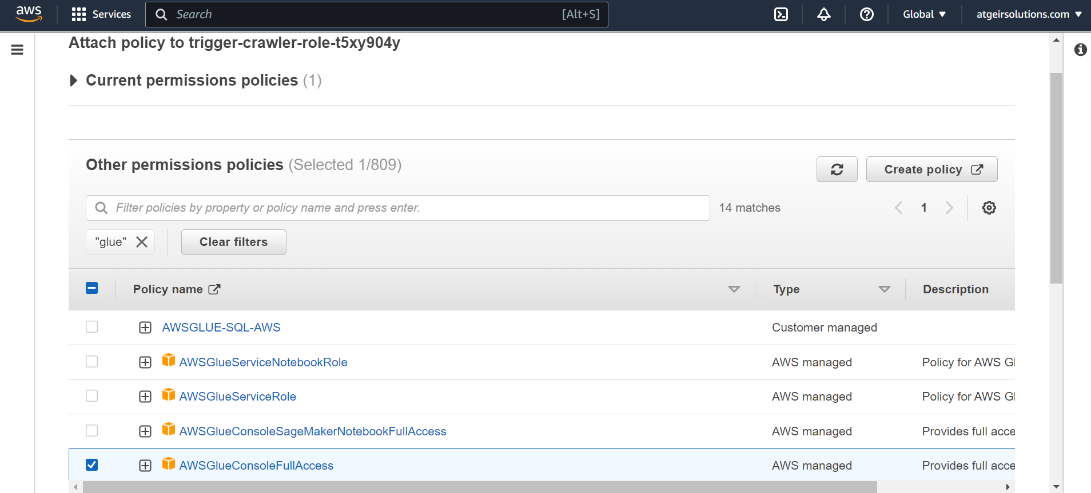

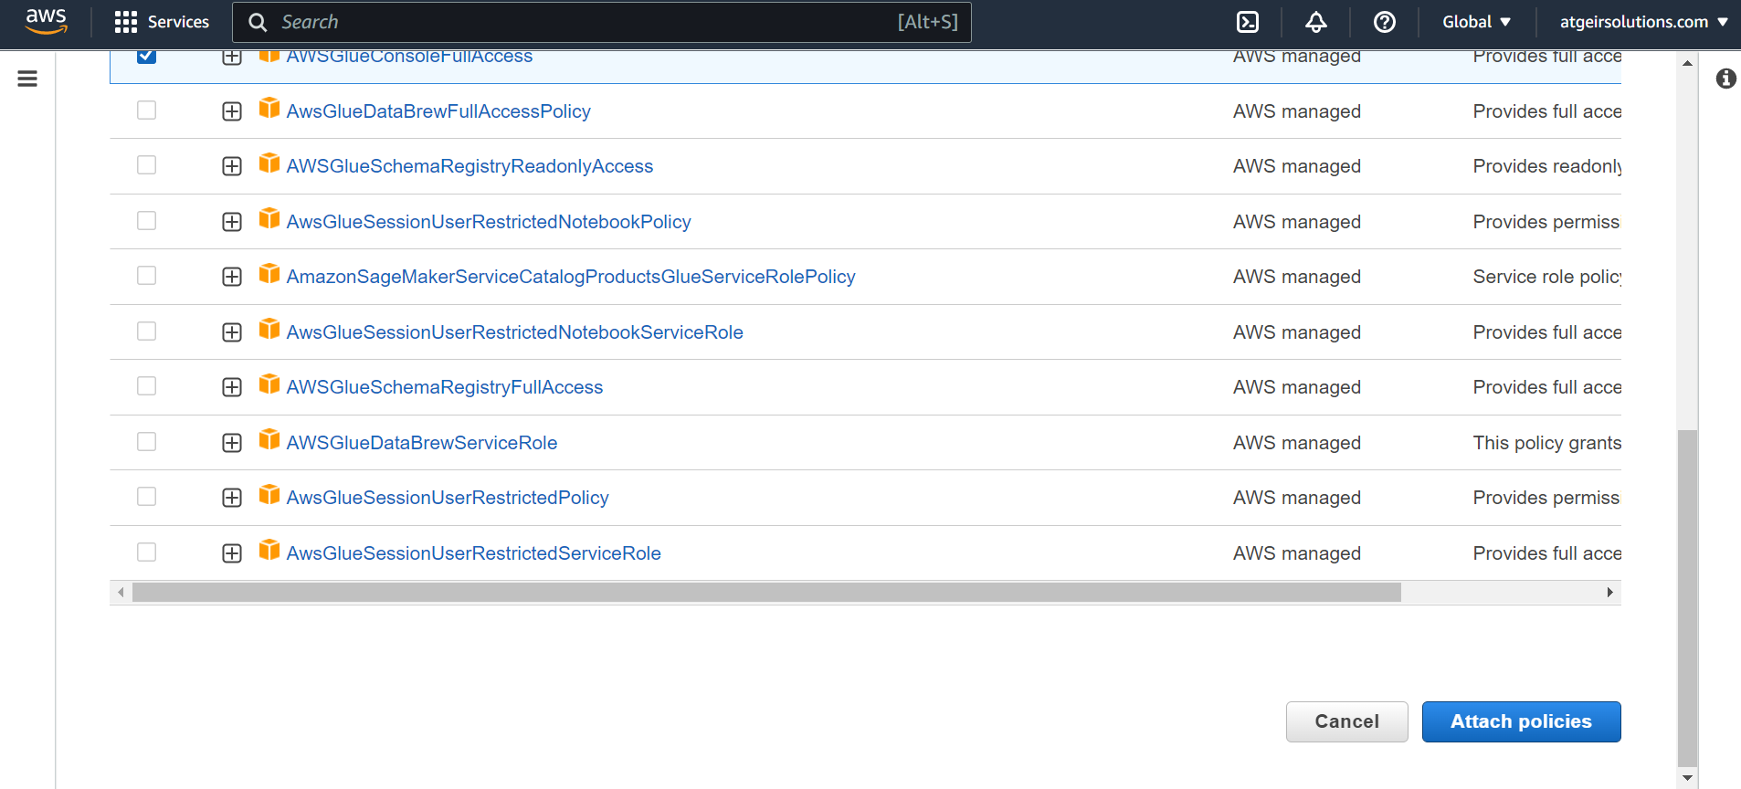

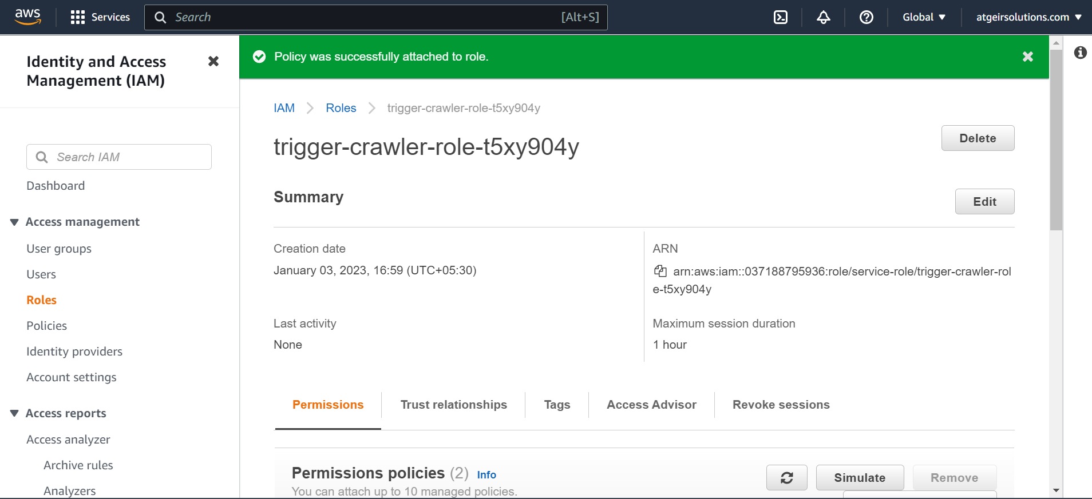

Run the lambda code

